ST. PATRICK’S DAY CHALLENGE
Complete each section of the 4-leaf clover for a Lucky Day!

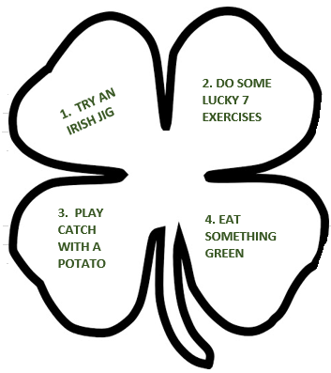

Try an Irish Jig. A traditional Irish jig is a series of hops and steps that repeat themselves over and over again. The steps are very simple, either stepping forward or taking steps backwards, but the hops can require some practice in getting the timing and coordination right. This is fun and challenging, to give it a try watch the following video: https://www.youtube.com/watch?v=9XCHoeOTFs8

Do some lucky 7 exercises. Complete the following: 7 jumping jacks, 7 push-ups, 7 sit-ups, 7 mountain climbers, 7 second run in place. Repeat as many times as desired.

Play catch with a potato. Go outside and play some catch, of course you can use a ball instead, or a potato if your parents allow? Try one-handed catches, see how far away you can get from a partner, try running catches. Don’t drop that potato, unless of course you are having mashed potatoes for dinner.

Eat something green. Eat something healthy this St. Patrick’s Day, maybe a green apple, green beans, celery, or salad.

