CARD DECK WORKOUT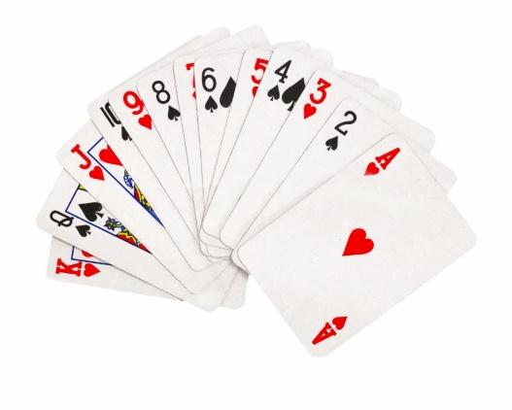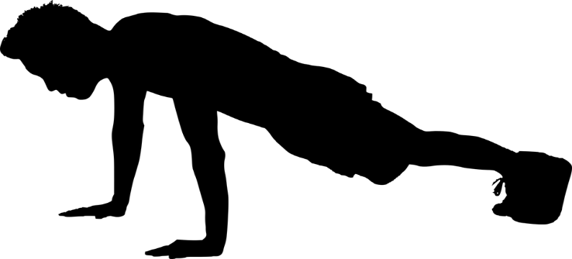

Growing up as a child, and even to this day, the card deck workout is one of my favorite ways to complete a home work out. All you need is a deck of cards, a small amount of space, and a creative imagination. Before the workout you make up your own guidelines. Most of the time I simply alternate push-ups with ab crunches. The cards flipped over determine how many repetitions you do of each exercise. For example, if I was alternating push-ups and crunches, I would first turn over a card and do that many push-ups (A=1, 2=2, 3=3, and so forth, all face cards = 10 reps). The next card would determine how many crunches I would do. I would then flip card after card alternating my push-ups and crunches. This example however can be quite challenging, but that doesn’t mean many of you kids can’t do it. One way of making this workout easier is by adding more exercises. For example I could choose to d 4 exercises: push-ups, vertical jumps, crunches, run in place. I would then proceed to pick a card and do that many push-ups. My next card would determine how many vertical jumps I do, next card determines my crunches, and the next card determines how many seconds I run in place. If I repeated this 13 times I would finish the entire deck of cards! Go ahead and use my examples, or I encourage you to make up your own exercise. You could even alternate cards with a partner. Be creative and have fun!

WHEN THE WORKOUT IS COMPLETE YOU WILL HAVE PERFORMED 340 REPETITIONS!

